**Modified entities and entries compilation**

* 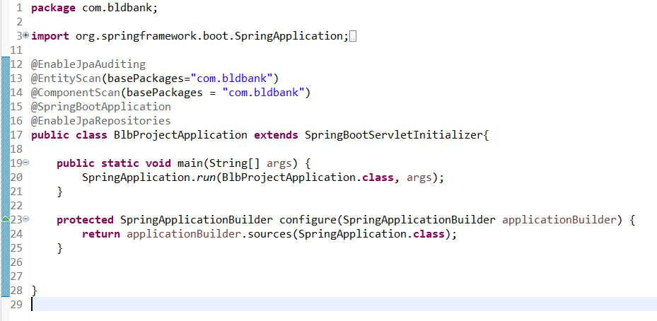BlbProjectApplication.java
* 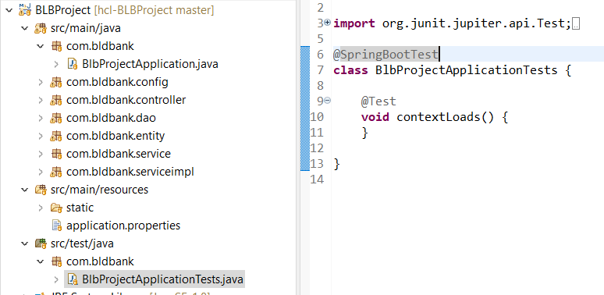Class modifications-
* 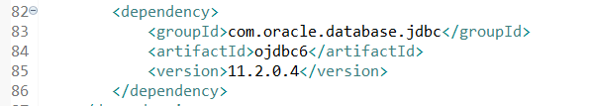Pom.xml modifications